Sleep, Parasomnias, and Psychological Adjustment Among Students with Different Disabilities

Fichten, C., Havel, A., Libman, E., Bailes, S., Jorgensen, Qin, Y., Liao, H., Creti, L., Vasseur, A., Zlotea, B, Budd, J. & Vo, C.
2024

Parasomnias are “disorders characterized by abnormal behavioral, experiential, or physiological events occurring in association with sleep, specific sleep stages, or sleep-wake transitions” (American Psychiatric Association, 2022, p. 451). Parasomnias among postsecondary students are not well documented. This is especially true for students with different types of disabilities. Therefore, the present study investigates parasomnias, sleep quality, insomnia, chronotype, and sleep disorders, as well as related aspects such as daytime functioning and well-being, in a sample of post-secondary students with different disabilities.

It is well known that sleep problems are linked to poorer academic performance (e.g., Prichard, 2020; Toscano-Hermoso et al., 2020), making the study of sleep related disorders an important consideration in research on post-secondary populations. A variety of studies have reported on the positive statistical relationship among sleep, mental health and single parasomnias (e.g., Benham, 2022; Jalal & Hinton, 2015; Petrov et al., 2014; Wróbel-Knybel et al., 2022). In addition, studies that do exist on postsecondary students and parasomnias typically show that higher levels of depression, anxiety, neuroticism, worry, and post-traumatic stress disorder (PTSD) are related to parasomnias (Alshahrani et al., 2023; Kelly, 2016; Jalal & Hinton, 2015; Petrov et al., 2014; Wróbel-Knybel et al., 2022).
Studies on postsecondary students and parasomnias usually include large numbers of students with disabilities. For example, in Canada, between 18% and 30% of college and university students have a disability (Canadian University Survey Consortium, 2020, 2021). Similarly, in the United States of America, 21% of university students reported having a disability (National Center for Education Statistics, 2023). The most common disabilities reported in a recent Canadian study were mental health related disabilities and attention deficit hyperactivity disorder (ADHD) (Fichten et al., 2022). Therefore, including these students as participants in studies may significantly bias the results.
Among those studies that did not exclude students with disabilities, a recent study by Kirwan and Fortune (2021) reported on the one-year prevalence rates of parasomnias among 135 university students in Ireland. This study showed that 98% of the students had experienced at least one parasomnia during the past year. The most common parasomnias reported were hypnic jerks, nightmares, sleep talking, nocturnal leg cramps, hypnagogic/hypnopompic hallucinations, and rhythmic leg movements while falling asleep. A study conducted by Alshahrani et al. (2023) in Saudi Arabia consisted of a sample of 1296 university students and found that during the past 6 months 81% reported at least one parasomnia. The most frequently reported parasomnias included sleep-talking, nightmares, and confusional arousals. A two-week study by Oluwole (2010) found that among 58 Nigerian university students the incidence of any parasomnia was 21%, with the most commonly reported parasomnias being hypnic jerks, nightmares, sleep paralysis and sleepwalking.

We conducted a study of 77 post-secondary students who were specifically selected because they self-identified as having no disabilities (Fichten et al., 2024). This study showed that most students (i.e., 92%) had several parasomnias during the past year with nightmares, hypnic jerks, sleep talking, sleep-related bruxism, and nocturnal leg cramps being most common
However, there is no study that has studied a variety of parasomnias or psychological and sleep related variables among post-secondary students with various disabilities. It is our goal here to do this.

Present Study

What is lacking is information on parasomnias and related psychological and sleep information on students with different disabilities. Since the literature suggests that those with mental health related disabilities such as anxiety and depressive disorders are more likely to have a variety of parasomnias and other sleep and mental health related disabilities, we divided our sample of current and recent postsecondary students into three groups: those with mental health related disabilities, those with other disabilities, and those with no disabilities. Since the literature suggests that students with different impairments may have specific parasomnias, we also provide information on several groups of students with different disabilities since the literature suggests that students with different impairments may experience specific parasomnias. For example, much of the literature deals with attention deficit hyperactivity disorder (ADHD), a very common disability among postsecondary students (Fichten et al., 2022). Although studies typically show that individuals with ADHD report a variety of sleep problems, the results do not elaborate on specific problems (Corkum et al., 2023). The same is true for other disabilities such as pain, chronic pain and health conditions, and physical disabilities (de la Vega et al., 2019).

Hypotheses

- Over 80% of participants with disabilities will report experiencing at least one parasomnia.
- Participants with mental health related disabilities will report having more parasomnias as well as more psychological and sleep related problems than those with other disabilities.
- Participants with disabilities other than mental health related disabilities will report experiencing more parasomnias and more psychological and sleep related problems than those without disabilities.
- The most common parasomnias for all of the participants will include hypnic jerks, nightmares, and nocturnal leg cramps.
- The relationship among parasomnias, other psychological and sleep related measures as well as well-being and other daytime distress and sleep disorders will be strong for all groups.

Method
Participants

Two hundred and two current postsecondary students participated or recent (were post-secondary students in the past five years) participated: 125 with and 77 without disabilities. Participants could self-report one or more of the disabilities listed in Table 1. Of those who indicated having a disability, 50% reported having a single disability while 50% reported two or more disabilities. Overall, the 125 participants reported 232 disabilities. Table 1, shows that, among self-reported disabilities, mental health related disabilities were the most common, followed by ADHD, chronic health problems, and learning disabilities.

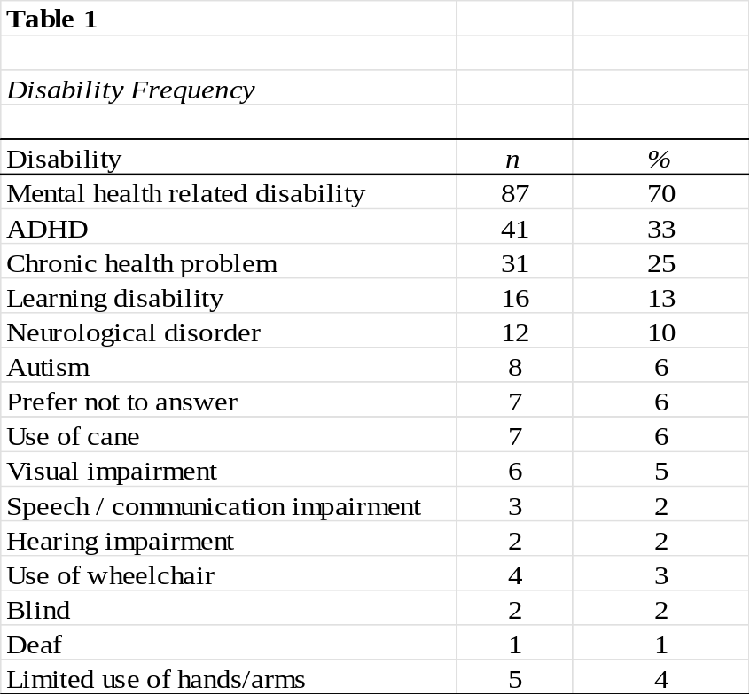
As shown in Table 2 and by the Chi Square show, there were significantly more females among students with mental health related disabilities than among nondisabled students, X² (1,192) = 9.16, p =.010. Ten students indicated a nonbinary gender. Given that a substantial number of students reported a mental health related disability, in subsequent analyses, we divided the sample into three groups: participants with mental health related disabilities (n = 87), those with any other disabilities (n = 38), and students without disabilities (n = 77).

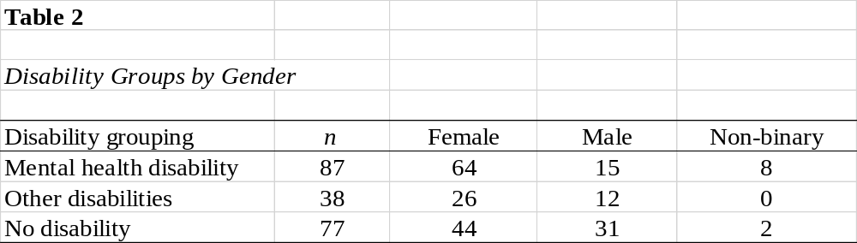

As reported in previous studies (e.g., Fichten et al., 2022), the results of an ANOVA (F (2,199) = 8.25, p = 001, ηp² =.077) found that students with mental health related (M = 24.93) and other disabilities (M = 25.00) were significantly older than those without disabilities (M = 22.53). However, there was no significant age difference between males and females in the two disability groups or between males and females without disabilities.

Measures
Demographics. Participants reported their gender (textbox), age, the presence or absence of the 14 disabilities reported in Table 1, and whether they were currently or recently (during the past five years) a post-secondary student.
Munich Parasomnia Screening Questionnaire (MUPS) (Fulda et al., 2008). This 21-item measure evaluates the frequency of experiencing 21 parasomnias (see Table 3). We were interested in the one-year prevalence, so we modified the MUPS frequency scoring to a 6-point Likert-type scale (1 = never, 2 = very rarely, 3 = rarely, 4 = sometimes, 5 = often, 6 = very often during the past year). Fulda et al. (2008) reported good validity for this measure. Heinzer used a non-validated French language version (R. Heinzer, personal communication, June 26, 2023). We made changes to Heinzer’s version to reflect French language usage specific to Canada. It is important to note that the MUPS categories do not correspond with the current ICDS-3 classification (Sateia, 2014).
This measure consists of two frequency related scores: how often people report experiencing each parasomnia using the following scale (sum of 1= never to 6= very often) and the total number of parasomnias that people report experiencing out of a total score out of 21. For each MUPS item they experienced we also asked participants to indicate how disturbing they found the parasomnia on a 10-point scale (1= not at all disturbing to 10 = very disturbing).
Sleep Questionnaire (Fichten et al., 1995). This measure is typically used clinically. We utilized three items scored on 10-point scales: Are you a good or poor sleeper? What was the quality of your sleep? How difficult is it to concentrate?
Insomnia Severity Index (ISI) (Bastien et al., 2001). The purpose of the ISI is to measure insomnia severity. It is a 7-item instrument with a range of scores from 0 to 28, with higher scores indicating greater severity of insomnia.
Reduced Morningness-Eveningness Questionnaire (rMEQ). Adan and Almirall’s (1991) five-item version of the original Horne and Ostberg Morningness-Eveningness Questionnaire was employed. Scores range from 4 to 25, with higher numbers indicating more morningness and lower numbers indicating more eveningness.
Revised Eysenck Personality Questionnaire (EPQR-A Neuroticism subscale (Francis et al., 1992). This short version of the neuroticism sub-scale consists of 6 items which participants answer by indicating yes or no. Lower scores indicate higher neuroticism.

Sleep Symptoms Checklist (SSC) Adapted from Bailes et al. (2009), this 21-item measure has four frequency subscales: insomnia, daytime distress, sleep disorder, and psychological maladjustment. The measure uses the following scale (0 = never, 1 = sometimes, and 2 = often). Higher scores indicate worse functioning.
Single-Item PTSD screener (SIPS) (Gore et al., 2008). This single item screening measure of posttraumatic stress disorder was validated by its authors. It asks the following, “During the last 12 months were you bothered by a past experience that caused you to believe you would be injured or killed?” Scoring is as follows: 0 = Not applicable, 1 = Not bothered at all, 2 = Bothered a little, 3 = Bothered a lot. Higher scores indicate a higher level of disturbance resulting from traumatic events.

Quality of Life Enjoyment and Satisfaction Questionnaire - Short Form (Q-LES-Q-SF) (Schechter et sl., 2007). This 16-item measure evaluates well-being. It uses a 5-point scale (1= very dissatisfied to 5 = very satisfied) and asks about overall satisfaction with a variety of aspects related to one’s physical health, daily activities, and personal relationships. Scores vary from 16 to 80, with higher scores being indicative of greater enjoyment or satisfaction.

Hospital Anxiety and Depression Scale (HADS) (Zigmond & Snaith, 1983). This is a self-report measure with two sub-scales, namely anxiety and depression, each consisting of seven items. Response options for both depression and anxiety range from zero to three, with some items using reverse scoring. Lower scores indicate the presence of fewer indicators of anxiety or depression.

Procedure
We conducted a bilingual (English, French) online survey between October and December 2023 and between January and March of 2024 (LimeSurvey, V3). The host institution’s Research Ethics Board approved the study (Certificate: FICHC23244335). Participant recruitment proceeded as follows: (1) email invitations were sent to Canadian postsecondary students who had participated in our previous research and had indicated that we could contact them for future studies, (2) announcements were emailed to discussion lists focusing on Canadian postsecondary education, and (3) student team members recruited friends and acquaintances. All students were participating in a larger investigation, and each participant who completed the survey received a $30 Amazon gift card.
Results
Parasomnias
One hundred and twenty-four (99%) of the 125 participants with disabilities reported at least one parasomnia and participants reported on average six different parasomnias. Among those without disabilities, 71 of 77 participants (92%) reported at least one parasomnia, while reporting an average of four different parasomnias. Table 3 presents the frequency of each of the 21 parasomnias for each disability category for students with and without disabilities.

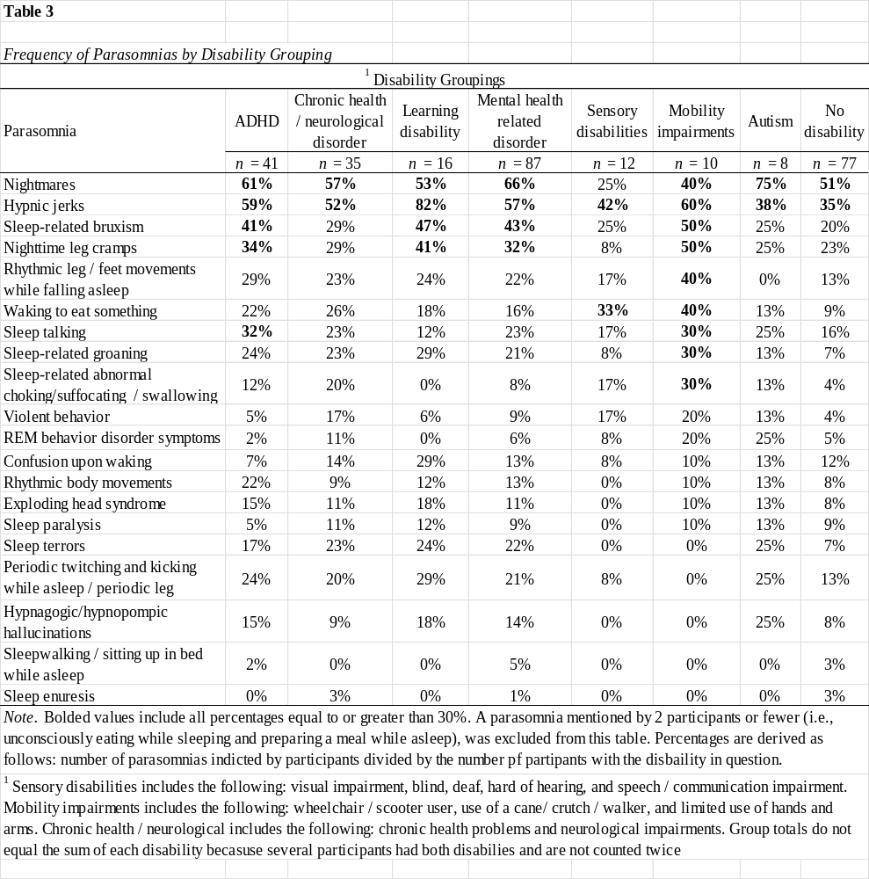
Results in Table 3 indicate that students with no disabilities as well as those with autism and those with chronic health/neurological disabilities experienced the fewest parasomnias, although all groups reported nightmares and hypnic jerks. Most participants with disabilities reported sleep-related bruxism, and nighttime leg cramps. Students with mobility impairments reported the largest number of parasomnias. The least frequently reported parasomnias were unconsciously eating while asleep, sleep enuresis. sleepwalking / sitting up in bed while asleep, and hypnagogic/hypnopompic hallucinations.
A subset of student participants who experienced the parasomnia rarely to very often (i.e., score =>3 on the 6-point frequency scale) provided ratings about how disturbing they found these. Table 4 shows the mean disturbance score for each parasomnia type for participants with and without disabilities, with a significant difference for only one parasomnia, namely hypnagogic/hypnopompic hallucinations.
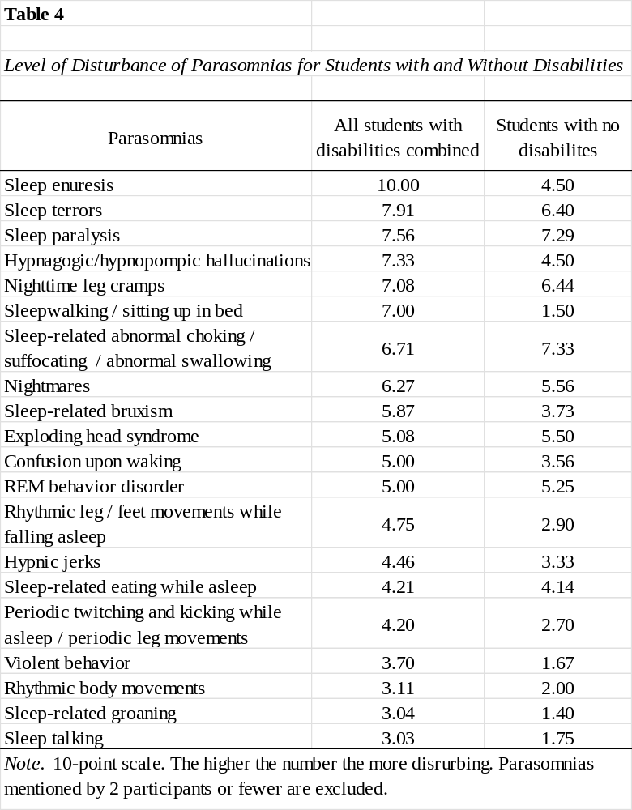

Other Variables
To examine the relationship between disabilities and sleep related variables we compared scores of participants with mental health related disabilities, other disabilities and no disabilities. Given the significant age difference between participants with and without disabilities, we first conducted multivariate analysis of variance comparisons with age as the covariate (MANCOVA). Since we conducted one questionnaires two weeks after the other, resulting in slightly different sample sizes, we conducted two separate MANCOVAs. Both were significant, F(26,374)=5.55, p<.001, η_{p}²=.278 and, F(6,310)=3.13, p =.005, η_{p}²=.057. These were followed by univariate analysis of covariance comparison on the 16 variables.
Although there was a significant difference between the number of males and females in the mental health related disabilities group, t-test comparisons between scores of males and females resulted in only two significant results among the 16 variables. Moreover, both of these significant results were at the .05 level. Therefore, subsequent analyses group males and females with mental health related disabilities together.
Variables of interest in Table 5 are grouped into three categories: parasomnias, sleep, and psychological. Results indicate that participants with mental health related disabilities generally had significantly worse scores than participants with other disabilities, who generally had poorer scores that those with no disabilities. Only three variables showed no significant differences among the three groups: rMEQ, well-being, and HADS depression. Participants with other disabilities did not differ from those with no disabilities for the following five variables: being a good vs poor sleeper, having difficulty concentrating, number of parasomnias, frequency of experiencing parasomnias, and HADS anxiety.
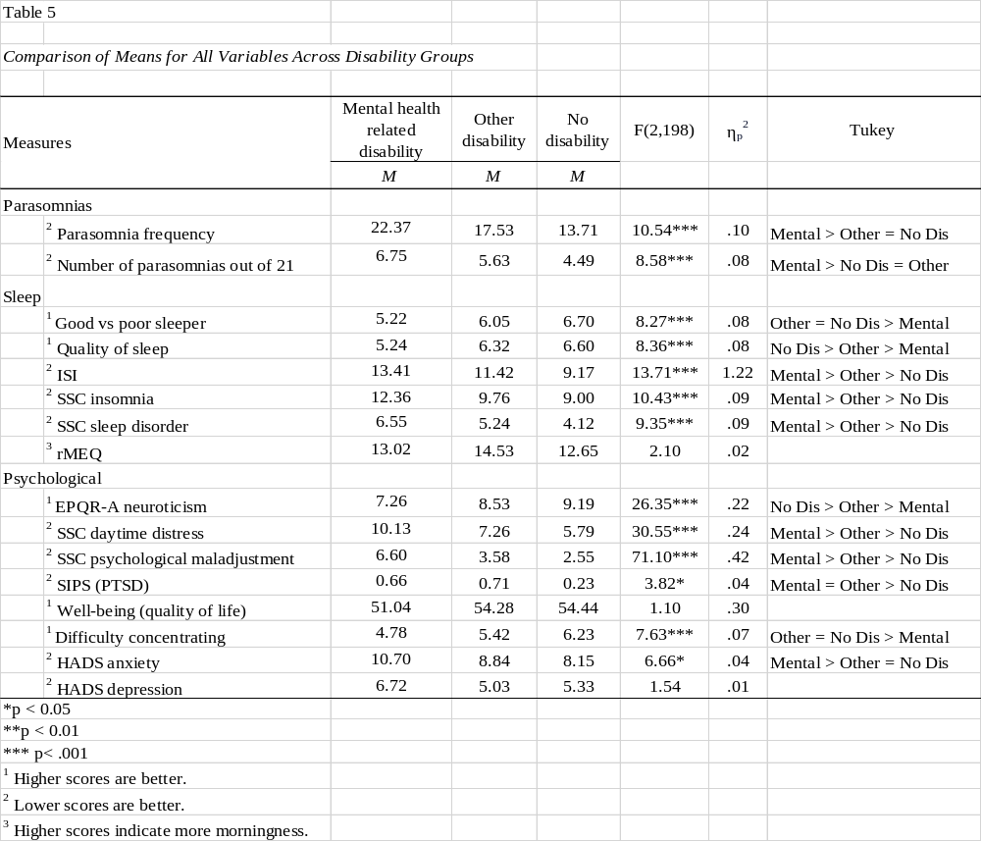
Table 6 shows correlations between the two parasomnia scores and the other 14 sleep and psychological variables. Scores of participants with mental health related disabilities are above the diagonal and scores of those with no disabilities below. Because of the diversity of disabilities among students with other disabilities, we decided not to examine correlations for this group. Although many coefficients are significant, we only explore coefficients of .400 and greater.
Results show that among participants without disabilities there is a significant relationship between the two parasomnia variables and between both of these and one sleep variable: SSC sleep disorders. There was no significant relationship between either parasomnia variable and any of the psychological measures.
Among students with mental health related disabilities, there is a significant relationship between the same two parasomnia variables as well as between these and SSC sleep disorders and three psychological variables: EPQR-A neuroticism, SSC daytime distress, and SSC psychological maladjustment.

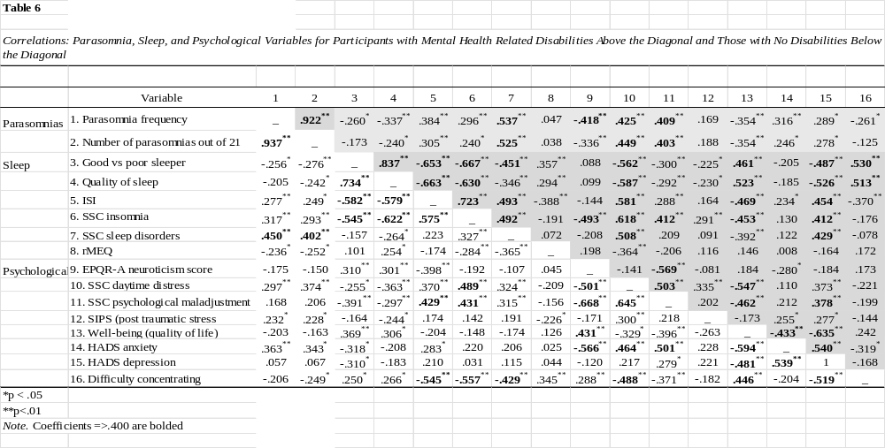

For both groups of participants, sleep related variables are closely related to each other (e.g., good vs. poor sleep, quality of sleep, ISI, SSC insomnia). Most psychological variables are closely related to each other. Among participants with mental health related disabilities, there is a relationship between sleep variables and depression and other psychological variables, as well as with difficulty concentrating.
It is noteworthy that among participants with mental health related disabilities, SSC daytime distress and well-being have significant relationships with almost all sleep related variables as well as with most psychological variables.
rMEQ (morningness-eveningness) and SIPS (post-traumatic stress disorder) scores are not closely related to any other variables for either group.
Discussion
Parasomnias
Consistent with hypothesis 1 and with data reported by others (Kirwan & Fortune, 2020; Alshahrani et al., 2023), our findings show that over 90% of participants, both those with and without disabilities, reported at least one parasomnia during the past year. Moreover, those participants with multiple parasomnias reported an average of five different ones. As predicted in hypotheses 2 and 3, participants with mental health related disabilities reported significantly more parasomnias than those with other disabilities. However, hypothesis 3 was not confirmed; this stated participants with disabilities other than mental health would have more parasomnias than those without disabilities.
Although the sample sizes were small, descriptive results show that three groups (i.e., no disability, chronic health / neurological disorder, and autism) reported the fewest parasomnias. Those with mobility impairments reported the largest number. Participants with mental health related disorders, ADHD, and learning disabilities reported the second largest number.
As reported in the literature (Fichten et al., 2024; Kirwan & Fortune, 2021; Oluwole, 2010), and predicted in hypothesis 4, the most common parasomnias reported were nightmares, hypnic jerks and nocturnal leg cramps. The least common were unconsciously eating while asleep, hypnagogic/hypnopompic hallucinations, sleepwalking / sitting up in bed, and sleep enuresis.
For those who experienced parasomnias, the following were reported as being especially disturbing: sleep enuresis, sleep terror, sleep paralysis, hypnagogic/hypnopompic hallucinations, nocturnal leg cramps, sleep related abnormal choking / suffocating, swallowing, nightmares, and acting out a dream. It is important to note that frequency and severity of disturbance are not necessarily related. For example, sleep enuresis, which few participants reported experiencing, brought about a high level of disturbance.
Other Variables
We were also interested in the relationship of parasomnias to psychological and other sleep related variables. Therefore, we conducted two types of analyses. First, we examined possible similarities and differences on 13 sleep and psychological variables among the three groups. Second we conducted correlational analyses to evaluate the relationships among variables.
Consistent with hypotheses 2 and 3, results show that participants with mental health related disabilities generally had significantly poorer scores than those with other disabilities and both groups generally had poorer scores than those with no disabilities on five of the six sleep variables and on seven of the eight psychological variables.
Relationships Among Variables
Parasomnias. It is not surprising that the findings on the relationship between parasomnias and other variables show that for both participants with mental health related disabilities and for those with no disabilities, parasomnias are closely related to measures of sleep disorders, including restless legs and sleep apnea.
Sleep and psychological variables: Participants with mental health related disabilities. What is more interesting is that for participants with mental health related disabilities, parasomnias are also related to difficulty concentrating - a skill needed for academic success - as well as to daytime distress and two psychological variables. Moreover, for this group daytime distress and well-being are linked to almost all sleep related variables and to most psychological variables.
For participants without disabilities, the relationships among variables are not clear. Thus, the part of hypothesis 6 that applies to participants with mental health related disability is confirmed while that related to participants with no disabilities is not. This was found even though another study reported that poor sleep was related to depressive symptoms among Brazilian college students who were not described as having any disabilities (Ramos et al., 2021), as well as among student athletes (Grandner et al., 2021).
Limitations
While our study contributes valuable insights about parasomnias and psychological and sleep variables, especially among students with disabilities, there are limitations that warrant attention in future research. First there were more females than males, especially in the metal health related disabilities group; this is common among individuals with mental health related conditions (Maser et al., 2019). Second, all responses were based on self-report. Third, some parasomnias such as sleep terrors, sleep talking, and REM sleep behavior disorder symptoms may be under-reported because these require corroboration from a bed partner.

Implications
- Parasomnias among post-secondary students, especially those with disabilities, are very common. Informing post-secondary professionals of this prevalence could impact on their approach to intervention. This is important because sleep disturbances often have a negative impact on academic performance.
- More attention needs to be paid not only to parasomnias, but also to psychological and sleep related concerns among students with mental health and other disabilities. It could be detrimental to students’ wellbeing if we focus solely on the symptoms of the primary disability and disregard co-morbid conditions. For example, individuals with mobility related disabilities need special attention as they had the largest number of parasomnias.

- Information on managing parasomnias, especially the common and disturbing ones, should be made available directly to students as they may be reluctant to seek professional help. For those students open to meeting with a professional there is a paucity of mental health services, resulting in long waiting lists. Providing students with strategies for self-management may be a worthwhile approach.
- Poor daytime functioning and concentration are linked to parasomnias for students with mental health related disabilities, as are sleep problems and poor psychological functioning linked to daytime distress and well-being. For students experiencing difficulties in daytime functioning, regardless of whether they have a self-reported disability, universal design strategies involving flexible class scheduling and access to online lectures could be beneficial.

References
Adan, A., & Almirall, H. (1991). Horne and Östberg morningness-eveningness questionnaire: A reduced scale. Personality and Individual Differences, 12(3), 241–253. http://dx.doi.org/10.1016/0191-8869(91)90110-W
Al Salmani, A. A., Al Shidhani, A., Al Qassabi, S. S., Al Yaaribi, S. A., & Al Musharfi, A. M. (2020). Prevalence of sleep disorders among university students and its impact on academic performance. International Journal of Adolescence and Youth, 25(1), 974–981. https://doi.org/10.1080/02673843.2020.1815550
Alshahrani, S. M., Albrahim, R. A., Abukhlaled, J. K., Aloufi, L. H., Aldharman, S. S., Albrahim, R., & Aloufi, L. (2023). Parasomnias and associated factors among university students: A cross-sectional study in Saudi Arabia. Cureus, 15(11), Article e48722. https://doi.org/10.7759%2Fcureus.48722
American Psychiatric Association. (2022). Diagnostic and statistical manual of mental disorders (5th ed., text rev.). https://doi.org/10.1176/appi.books.9780890425787
Bailes, S., Baltzan, M., Rizzo, D., Fichten, C. S., Grad, R., Wolkove, N., Creti, L., Amsel, R., & Libman, E. (2009). Sleep disorder symptoms are common and unspoken in Canadian general practice. Family Practice, 26(4), 294–300. https://doi.org/10.1093/fampra/cmp031
Bastien, C. H., Vallières, A., & Morin, C. M. (2001). Validation of the Insomnia Severity Index as an outcome measure for insomnia research. Sleep Medicine, 2(4), 297-307. https://doi.org/10.1016/s1389-9457(00)00065-4
Benham, G. (2022). Sleep paralysis in college students. Journal of American College Health, 70(5), 1286–1291. https://doi.org/10.1080/07448481.2020.1799807
Canadian University Survey Consortium. (2020). 2020 middle-years student survey: Master report: June 2020. https://cusc-ccreu.ca/?download=823
Canadian University Survey Consortium. (2021). Graduating student survey: Master report: June 2021. https://cusc-ccreu.ca/?download=922
Corkum, P., Bertrand, M., Ilie, A., & Rajda, M. (2023). ADHD and sleep problems. In J. L. Matson (Ed.), Clinical handbook of ADHD assessment and treatment across the lifespan (pp. 243-275). Springer. https://doi.org/10.1007/978-3-031-41709-2_10
de la Vega, R., Miró, J., Esteve, R., Ramírez-Maestre, C., López-Martínez, A. E., & Jensen, M. P. (2019). Sleep disturbance in individuals with physical disabilities and chronic pain: The role of physical, emotional and cognitive factors. Disability and Health Journal, 12(4), 588-593. https://doi.org/10.1016/j.dhjo.2019.04.001
Fichten, C. S., Creti, L., Amsel, R., Brender, W., Weinstein, N., & Libman, E. (1995). Poor sleepers who do not complain of insomnia: Myths and realities about psychological and lifestyle characteristics of older good and poor sleepers. Journal of Behavioral Medicine, 18(2), 189–223. https://doi.org/10.1007/BF01857869
Fichten, C., Jorgensen, M., Havel, A., Legault, A., & Budd, J. (2022). Academic performance and mobile technology use during the COVID-19 pandemic: A comparative study. Journal of Postsecondary Education and Disability, 35(1), 61–76.
Fichten, C. S., Libman, E., Bailes, S., Jorgensen, M., Havel, A., Qin, Y., Creti, L., Liao, H., Zlotea, B., Vo, C., Budd, J., Vasseur, A., Pierre-Sindor, T., & Costin, G. (2024). Parasomnias in post-secondary students: Prevalence, distress, and coping strategies. Behavioral Sciences, 14(8), Article 646. https://doi.org/10.3390/bs14080646
Fulda, S., Hornyak, M., Müller, K., Cerny, L., Beitinger, P. A., & Wetter, T. C. (2008). Development and validation of the Munich Parasomnia Screening (MUPS): A questionnaire for parasomnias and nocturnal behaviors. Somnologie, 12, 56–65. https://doi.org/10.1007/s11818-008-0336-x
Francis, L. J., Brown, L. B., & Philipchalk, R. (1992). The development of an abbreviated form of the revised Eysenck Personality Questionnaire (EPQR-A): Its use among students in England, Canada, the U.S.A. and Australia. Personality and Individual Differences, 13(4), 443-449. https://doi.org/10.1016/0191-8869(92)90073-X
Gore, K. L., Engel, C. C., Freed, M. C., Liu, X., & Armstrong, D. W. (2008). Test of a single-item posttraumatic stress disorder screener in a military primary care setting. General Hospital Psychiatry, 30(5), 391-397. https://doi.org/10.1016/j.genhosppsych.2008.05.002
Grandner, M. A., Hall, C., Jaszewski, A., Alfonso-Miller, P., Gehrels, J. A., Killgore, W. D., & Athey, A. (2021). Mental health in student athletes: associations with sleep duration, sleep quality, insomnia, fatigue, and sleep apnea symptoms. Athletic Training & Sports Health Care, 13(4), e159-e167. https://doi.org/10.3928/19425864-20200521-01
Jalal, B., & Hinton, D. E. (2015) Sleep paralysis among Egyptian college students: Association with anxiety symptoms (PTSD, trait anxiety, pathological worry). Journal of Nervous and Mental Disease, 203(11), 871-875. https://doi.org/10.1097/nmd.0000000000000382
Kelly, W. E. (2016). Some personality characteristics of college students reporting frequent nightmares. Sleep and Hypnosis, 18(3). 69-73. http://dx.doi.org/10.5350/Sleep.Hypn.2016.18.0110
Kirwan, E., & Fortune, D. G. (2020). Exploding head syndrome, chronotype, parasomnias and mental health in young adults. Journal of Sleep Research, 30(2), Article e13044. https://doi.org/10.1111/jsr.13044
Maser, B., Danilewitz, M., Guérin, E., Findlay, L., & Frank, E. (2019). Medical student psychological distress and mental illness relative to the general population: A Canadian cross-sectional survey. Academic Medicine, 94(11), 1781-1791.
National Center for Education Statistics. (2023). Number and percentage distribution of students enrolled in postsecondary institutions, by level, disability status, and selected student characteristics: Academic year 2019–20. U.S. Department of Education, Institute of Education Sciences.
Oluwole, O. S. A. (2010). Lifetime prevalence and incidence of parasomnias in a population of young adult Nigerians. Journal of Neurology, 257(7), 1141-1147. https://doi.org/10.1007/s00415-010-5479-6
Petrov, M. E., Lichstein, K. L., & Baldwin, C. M. (2014). Prevalence of sleep disorders by sex and ethnicity among older adolescents and emerging adults: Relations to daytime functioning, working memory and mental health. Journal of Adolescence, 37(5), 587-597. https://doi.org/10.1016/j.adolescence.2014.04.007
Prichard, J. R. (2020). Sleep predicts collegiate academic performance: Implications for equity in student retention and success. Sleep Medicine Clinics, 15(1), 59-69. https://doi.org/10.1016/j.jsmc.2019.10.003
Ramos, J. N., Muraro, A. P., Nogueira, P. S., Ferreira, M. G., & Rodrigues, P. R. M. (2021). Poor sleep quality, excessive daytime sleepiness and association with mental health in college students. Annals of Human Biology, 48(5), 382–388. https://doi.org/10.1080/03014460.2021.1983019
Sateia, M. J. (2014). International classification of sleep disorders. Chest, 146(5), 1387-1394. https://doi.org/10.1378/chest.14-0970
Schechter, D., Endicott, J., & Nee, J. (2007). Quality of life of ‘normal' controls: Association with lifetime history of mental illness. Psychiatry Research, 152(1), 45-54. https://doi.org/10.1016/j.psychres.2006.09.008
Toscano-Hermoso, M. D., Arbinaga, F., Fernández-Ozcorta, E. J., Gómez-Salgado, J., & Ruiz-Frutos, C. (2020). Influence of sleeping patterns in health and academic performance among university students. International Journal of Environmental Research and Public Health, 17(8), Article 2760. https://doi.org/10.3390/ijerph17082760
Wróbel-Knybel, P., Flis, M., Rog, J., Jalal, B., & Karakuła-Juchnowicz, H. (2022). Risk factors of sleep paralysis in a population of Polish students. BMC psychiatry, 22(1), Article 383. https://doi.org/10.1186/s12888-022-04003-0
Zigmond, A. S., & Snaith, R. P. (1983). The Hospital Anxiety and Depression Scale. Acta Psychiatrica Scandinavica, 67(6), 361-370. https://doi.org/10.1111/j.1600-0447.1983.tb09716.x

